Royal’s Sales Management System
A Software Requirements Specification Document presented to
the Faculty of the College of Computer Studies
Mindanao State University
In Partial Fulfillment of the Requirements for the course
CCC181

by:
Datungan, Mohamedin D.
Edres, Abdulazis
Gampong, Abdul Malik
Macalangcom, Cosmela O.
Macapantao, Arafat I.

Ms. Ilham O. Gamal
Instructor

November 2025
Table of Contents
1.0 Introduction……………………………………………………………………………....3
1.1 Company Overview……………………………………………………………….......3
1.2 Project/System Objectives…………………………………………………………….3
1.3 Project Conception…………………………………………………………………….4
1.4 Problem Statement…………………………………………………………………….4
1.5 Project Scope………………………………………………………………………..4-5
1.6 Project Vision…………………………………………………………………………5
1.7 Business Constraints…………………………………………………………………..5
1.8 Technology Constraints……………………………………………………………….6
1.9 Project Strategy………………………………………………………………………..6
1.10 Project Documentation and Communication……………………………………… ..7
1.11 Project Organization and Staffing Approach………………………………………7-8
2.0 Functional Requirements Specification………….………………………………………8
2.1 Software Functions……………………………………………………………………8
User Types……………………………………………………….……………………..8
Data Files……………………………………………………………….…………….8-9
Types of Reports………………………………………………………………….…….9
2.2 Use Case Diagram………………………………………………………………….9-10
2.3 Use Case Scenario……………………………………………………………………10
Appendix……………………………………………………………………………………11
A. Sample Forms…………………………………………………………………………11
B. Sample Report…...…………………………………………………………………11-12
C. References……………………………… …………………………………………….12

1.0 Introduction

1.1 Company Overview
This Sale Management System is an online sales and inventory platform designed to assist Royal in organizing and managing their sales operations more efficiently. The system aims to provide a centralized environment where administrators and staff can handle product listings, sales transactions, and essential business reports without relying on manual or semi-digital processes. By offering a simple and accessible interface, it provides Royal’s owners with the tools needed to manage sales activities with convenience and accuracy.
Many small businesses that operate online some still depend on traditional methods such as handwritten logs, spreadsheet tracking, and social media message-based transactions. These approaches often lead to data loss, miscommunication, and difficulties in tracking sales performance. This system addresses these challenges by offering an integrated platform that allows users to record transactions, monitor product availability, and generate organized reports that can guide better decision-making. Through this system, Royal can gain improved visibility over their operations, resulting in more timely and effective management.
According to Kumar & Saini (2022), sales management systems are essential for streamlining business operations, as they minimize manual errors and support faster, more accurate sales processing. Rahman et al. (2023) further emphasize that digitally enabled sales platforms improve productivity and competitiveness among small and medium enterprises by providing real-time access to reliable data. Additionally, TechTarget (2024) highlights that digital sales tools support informed decision-making by offering insights into sales trends, customer behavior, and revenue performance. Inspired by these findings, the Royal’s Sale Management System aims to deliver a modern, practical, and effective solution that enhances the management of sales while supporting the business growth and operational efficiency.

1.2 Project/System Objectives
The primary objective of this Royal’s Sales Management System is to provide an organized and efficient digital sales management platform for managing sales operations. The system aims to streamline essential sales processes to reduce reliance on manual work and ensure accurate and organized business transactions. By offering a structured and user-friendly solution, this system supports Royal’s owners and staff in handling their selling activities with greater ease and reliability.
Specific objectives include:
- Provide a centralized platform for recording and monitoring sales transactions.
- Maintain accurate and updated product information such as item names, descriptions, prices, and stock quantities.
- Generate meaningful sales and inventory reports to support data-driven decision-making.
- Implement secure login and user access control to ensure that only authorized personnel can manage system operations.
- Improve operational efficiency by reducing errors and delays commonly experienced in manual sales tracking.
1.3 Project Conception
The Royal’s Sale Management System was conceptualized in response to the growing need for automated digital sales tools among sellers, small enterprises, and emerging digital businesses. Many business owners continue to struggle with manual recordkeeping, message-based sales, and spreadsheet tracking, which often result in data inconsistencies, delayed processing, and difficulty in monitoring sales trends. The increasing shift toward e-commerce has highlighted the importance of adopting systems that can keep up with digital demands.
Recognizing these challenges, the project team conceptualized Royal’s Sales Management System as a platform designed to simplify and centralize the Royal’s sales management. The idea emerged from observing the common problems faced by business owner—such as inaccurate stock monitoring, misplaced transaction details, and the absence of organized reporting tools. By developing a unified system that integrates product information, sales recording, and reporting, this system will provide a more reliable and efficient way to manage the selling activities.
Furthermore, literature supports the need for digital sales systems in modern business environments. Studies emphasize that digital sales management tools improve accuracy, operational control, and business responsiveness (Kumar & Saini, 2022; Rahman et al., 2023).

1.4 Problem Statement
Just like many other small businesses, Royal still to relies on manual or semi-manual methods to manage their sales activities. These outdated processes—such as handwritten notebooks, spreadsheet logs, and informal message-based orders—are often prone to errors and inefficiencies. As a result, they experience several recurring problems, including:
- Inaccurate or incomplete sales records due to inconsistent tracking methods
- Delays in processing orders and compiling sales information
- Difficulty in organizing product data, leading to misinformation or pricing inconsistencies
- Limited reporting capabilities, making it hard for business owners to analyze performance or identify trends
These issues hinder the operational efficiency, weaken decision-making, and can negatively impact customer satisfaction. Without an organized and automated system, Royal may risk to losing important data, mismanaging products, and so on. The Royal’s Sale Management System is designed to solve these problems by providing a centralized, structured, and digital solution for managing the Royal’s sales records, product information, and essential reports.

1.5 Project Scope
The Royal’s Sale Management System focuses on developing a system that will help Royal with their essential aspects of sales to maintain organized and efficient operations. The system will provide functions that support product handling, sales recording, report generation, and user access control.
The scope of the system includes:
- Management of product information such as product name, price, description, and stock quantity
- Processing and recording of sales transactions purchase by customers.
- Monitoring of sales, inventory, and revenue-related reports
- Implementation of secure login and user-role based access for administrators and staff
- Desktop browser accessibility through a web-based interface
The system will not include features such as automatic inventory updates, customer purchase tracking, or third-party payment gateway integration in its initial scope. These enhancements may be considered in future iterations of the project.

1.6 Project Vision
The vision of the Royal’s Sale Management System is to establish a modern, efficient, and easy-to-use digital platform that supports the essential sales operations of Royal. The system aims to replace traditional manual processes with a streamlined and organized approach. By providing a reliable and structured platform, Royal’s Sales Management System envisions empowering Royal to operate more professionally, respond more quickly to customer demands, and maintain accurate and accessible sales information.
In the long term, Royal’s Sales Management System aspires to evolve into a fully scalable and adaptive platform that can support additional features such as automated inventory updates, digital receipts, customer records, and third-party integration. The system’s vision is to remain simple yet powerful—promoting efficiency, accuracy, and improved decision-making for businesses engaged in online selling.

1.7 Business Constraints

The development of the Royal’s Sale Management System is influenced by several business-related limitations that shape how the project is designed and executed. These constraints must be considered to ensure a feasible and realistic implementation of the system.
Key business constraints include:
- Budget Limitations: The project must be developed using free or open-source tools due to limited financial resources.
- Time Constraints: The system must be completed within the timeframe of the academic semester, requiring efficient planning and task distribution.
- Resource Availability: Hardware, software, and testing resources may be limited, affecting development speed and the scale of system testing.
- User Familiarity: Perhaps the users may have limited technological experience; thus, the system must remain straightforward and intuitive.
- Maintenance Capabilities: Long-term support or updates may be limited depending on the availability of project developers after the academic period.
These constraints guide the development team in prioritizing essential features while ensuring a functional and user-friendly system.

1.8 Technology Constraints
The Royal’s Sale Management System will be developed within specific technological boundaries to ensure practicality, compatibility, and feasibility within the available resources.
The technology constraints include:
- Platform Limitation: The system will be web-based and accessible through standard desktop browsers.
- Development Tools: The project will utilize HTML, CSS, JavaScript, React.js, Node.js and Tailwind as these languages are accessible, manageable, and compatible with the team’s skills.
- Database: MySQL will be used for data storage due to its reliability and availability in common local server setups such as XAMPP or WAMP.
- Server Environment: Development and testing will take place in a local server environment, which may limit real-world traffic testing.
- Security Limitations: The system will implement basic security features such as user authentication and input validation, but advanced encryption and security protocols may not be included due to time and resource constraints.
These constraints ensure that the project remains technically achievable while providing a functional and effective sales management platform.

1.9 Project Strategy
The development of the Royal’s Sale Management System will follow a structured and systematic approach to ensure that the project progresses smoothly and meets its intended goals. The team will adopt an Agile Development Model, which allows for clear planning, documentation, and step-by-step execution.
The project strategy includes:
- Requirements Analysis: Identifying system needs based on research and user requirements.
- System Design: Creating data structures, interface prototypes, and system architecture.
- Development: Implementing system modules using HTML, CSS, JavaScript, React.js, Node.js, Tailwind and MySQL.
- Testing: Conducting functionality testing, debugging, and user validation to ensure system accuracy and reliability.
- Deployment: Installing the system on a local server environment and demonstrating full functionality.
- Documentation: Preparing all required documents including the SRS, design diagrams, user manual, and final project report.
This strategy ensures that the system is developed in an organized, predictable, and quality-focused manner.

1.10 Project Documentation and Communication
The success of the Royal’s Sale Management System relies on effective documentation and communication throughout the development lifecycle. Clear documentation ensures that all project stages are properly recorded, while structured communication promotes teamwork and timely completion of project tasks.
Documentation Deliverables include:
- System Requirements Specification (SRS)
- Design Documents (ERD, DFD, interface layouts)
- Test Cases and Testing Results
- User Manual for system operation
- Final Technical Report detailing the entire development process
Communication Plan includes:
- Regular team meetings to discuss progress, assign tasks, and address issues
- Online communication platforms (e.g., Messenger, Google Drive) for collaboration and file sharing
- Scheduled consultations with the instructor for feedback and guidance
- Progress updates submitted at agreed milestones
By maintaining strong communication and thorough documentation, the team ensures transparency, accountability, and consistent progress throughout the development of the Royal’s Sales Management System.

1.11 Project Organization and Staffing Approach
The development of the Royal’s Sale Management System requires a clear organizational structure to ensure efficient collaboration, proper task distribution, and smooth progression throughout the project. Each member of the team will take on a role aligned with their strengths and responsibilities, allowing the project to be completed within the expected timeframe and quality standards. The staffing approach focuses on teamwork, accountability, and consistent communication to achieve the system’s objectives.
Team Roles and Responsibilities
Role | Responsibilities
Team Lead | Oversees the overall direction of the project; manages schedules; facilitates meetings; ensures timely completion of project milestones; coordinates communication among members and with the instructor.
Frontend Developer | Designs and implements the system’s user interface; ensures that the layout, navigation, and overall user experience are intuitive, responsive, and consistent across browsers and devices.
Backend Developer | Handles database integration and server-side functions; develops the core logic for product management, sales recording, and report generation; ensures data consistency and system functionality.
Documentation Lead | Prepares and maintains all necessary documentation including the SRS, design diagrams, test reports, and final technical outputs; ensures that documents follow academic standards and system specifications.
QA Tester | Conducts testing of system modules; identifies errors, inconsistencies, and usability issues; works closely with developers to ensure that the system meets functional and non-functional requirements before deployment.
Table. 1: Team Composition

2.0 Functional Requirements Specification

2.1 Software Functions
The Royal’s Sale Management System provides essential functions that support online sales operations. These functions ensure that users can manage products, record sales transactions, and generate reports in an organized and efficient manner.
User Types
The Royal’s Sale Management System defines different user roles to ensure proper access control and organized workflow. Each user type has specific responsibilities and access privileges based on their function in operating the Royal’s Sale platform.
User | Description | Access / Responsibilities
Admin | Acts as the highest-level user responsible for overseeing system operations. | Manage users, products, sales records, and all system reports.
Staff | Assists in daily business operations and sales activities.
  Record sales, update product details, and view summary reports
Data Files
The system stores all essential information in structured database tables. These data files ensure that products, users, and sales transactions are properly recorded, maintained, and retrievable for system operations and reporting.
Table Name | Description | Stored Information
User Table | Stores account information and assign roles. | Username, password, role, status
Product Table | Contains all product-related data. | Product ID, name, price, description, stock
Sales Table | Records every sale made through the system. | Transaction ID, date, product ID, quantity, total amount
Report Table | Stores generated report summaries for reference. | Report ID, date, type, details
Type of Reports
The system generates several types of reports that help administrators and staff analyze sales performance, monitor stock levels, and evaluate business profitability. These reports support decision-making and provide a clear overview of business activities.
- Sales Report – Summarizes all sales transactions over a specified time period.
- Inventory Report – Shows current stock quantities and highlights products with low availability.
- Revenue Report – Presents total revenue generated within a selected date range.
- Daily/Monthly Summary Report – Provides a compiled overview of sales activity for either a day or a full month.

2.2 Use Case Diagram
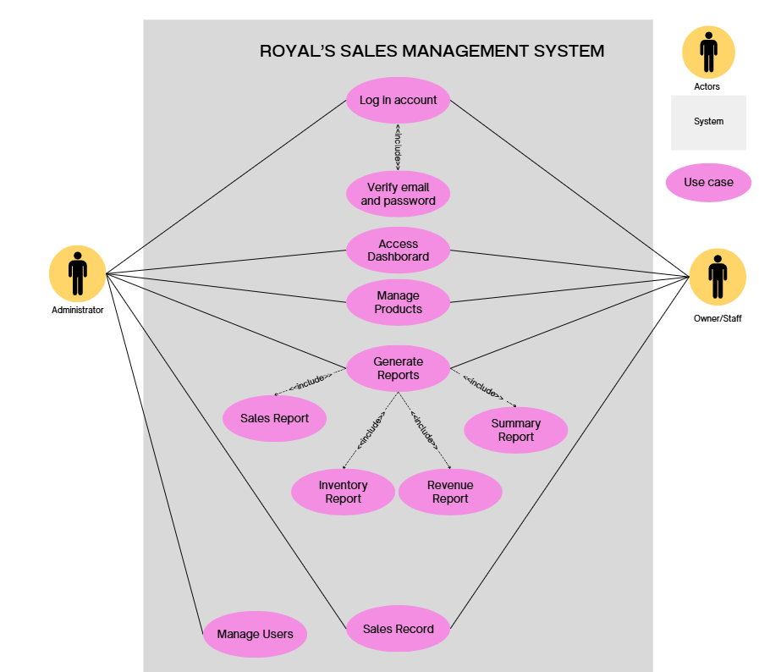
Table 1. Use Case diagram
This diagram will illustrate the system’s actors (Admin, Owner/Staff) and their interactions with the system.

2.3 Use Case Scenario

Table 1: USE CASE SCENARIO – Royal’s Sales Management System
Name | Royal’s Sales Management System
Requirement | FR1. This use case describes how the Royal’s Sale System enables users to record sales transactions, manage product information, and generate basic sales and inventory reports efficiently and accurately.
Actor | •Admin  • Owner/Staff
Pre-conditions | •The Admin & Staff must have a registered account and valid login credentials.  • The system must be connected to the database.  •The user must successfully log in before accessing any system functionality.
Trigger | The use case begins when the Owner/Staff needs to record a sale transaction or update product information within the Royal’s Sales Manage System.
Post-conditions | • All sales transaction records are accurately saved in the system database.  • The user session is securely terminated after logout.

Main Flow | The user login to the system and access the dashboard. From there, they record sales by selecting a product, entering the quantity, and confirming the sale. The system calculates the total amount, saves the transaction, and updates the report summaries. The user logs out after completing the operations.

Actor Action | System Response
1. Owner/Staff enters username and password, then clicks Login. | 2. System verifies credentials and displays the Dashboard.
3. Owner/Staff selects the Sales Module. | 4. System displays the list of products.
5. Owner/Staff selects a product to sell. | 6. System displays the sales entry form.
7. Owner/Staff enters quantity and confirms the transaction. | 8. System validates the input.
9. Owner/Staff clicks Save/Confirm. | 10. System stores the transaction in the database and displays a success message.
11. Owner/Staff opens the Reports Module. | 12. System generates sales and revenue reports in real time.
13. Owner/Staff logs out of the system. | 14. System ends the session and returns to the Login Page.

Exception Path – E1-1a | Invalid Login Credentials
Actor Action | System Response
1. Owner/Staff enters invalid credentials. | 2. System displays an error message and denies access.
 | 3. System reloads the Login Page.

Exception Path – E2-7a | Invalid Quantity Input
Actor Action | System Response
7. Owner/Staff enters an invalid quantity (e.g., negative or non-numeric). | 8. System displays: “Invalid quantity input. Please enter a valid number.”
 | 9. System displays the Sales Entry Form for correction.

Appendix

A. Sample Forms

These conceptual forms represent the user interfaces required for the system's core functions.
Form Name | Purpose | Key Fields / Elements | User Access
Login Page Form | To authenticate users and control access. | Username, Password, Login Button, System Logo/Name. | Admin, Owner/Staff
Product Management Form (Add/Edit) | To manage (add, edit, delete) product details and stock information. | Product ID (Auto-generated), Product Name, Price, Description, Stock Quantity. | Admin, Owner/Staff
Sales Entry Form | To process and record sales transactions made by customers. | Product Selection (Searchable Dropdown), Quantity, Total Amount (Calculated by system), Date/Time (Autofill), Save/Confirm Button. | Admin, Owner/Staff
User Management Form | To manage users (add/edit/delete accounts) and assign roles. | Username, Password, Role (Admin/Staff), Status (Active/Inactive), Save Button. | Admin Only

B. Sample Reports
The system generates reports to help administrators and staff analyze sales performance, monitor stock levels, and support data-driven decision-making.
Report Name | Purpose and Description | Key Data Stored (Source Table) | Conceptual Output Fields
Sales Report | Summarizes all sales transactions over a specified time period. | Sales Table | Transaction ID, Date, Product ID, Quantity, Total Amount.
Inventory Report | Shows current stock quantities and highlights products with low availability. | Product Table | Product ID, Product Name, Current Stock (calculated), Status (e.g., In Stock, Low Stock).
Revenue Report | Presents total revenue generated within a selected date range. | Sales Table, Report Table | Date Range, Total Revenue, Total Sales Count.
Daily/Monthly Summary Report | Provides a compiled overview of sales activity for a day or a full month. | Sales Table, Report Table | Date/Month, Total Transactions, Total Revenue, Average Transaction Value.

C. Reference
This section documents the external sources that provided theoretical support and validation for the system's necessity and design.
‎ • Kumar, P., & Saini, P. (2022). Cited for the finding that sales management systems are essential for streamlining business operations, as they minimize manual errors and support faster, more accurate sales processing.
‎ • Rahman, M. A., et al. (2023). Cited for emphasizing that digitally enabled sales platforms improve productivity and competitiveness among small and medium enterprises by providing real-time access to reliable data.
‎ • TechTarget (2024). Cited for highlighting that digital sales tools support informed decision-making by offering insights into sales trends, customer behavior, and revenue performance.‎

